Coronavirus (COVID-19)
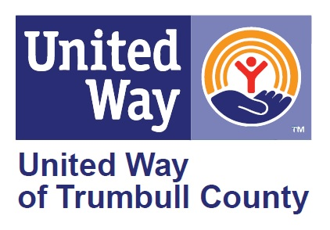
Internet and Cell Phone Resources

Internet Service Providers and Mobile Carriers:
During the COVID-19 crisis, local internet service providers are offering FREE WiFi hotspots and low-cost internet solutions. As Trumbull County students continue their courses online, United Way of Trumbull County wants to provide students a resource to access free and low-cost internet options as well as information on mobile carries response to COVID-19.

Free Wireless Hotspots:
- Xfinity WiFi hotspots across the country will be available to anyone who needs them for free – including non-Xfinity internet subscribers. To find an Xfinity WiFi hotspot, check the hotspot location map at wifi.xfinity.com or download the Xfinity WiFi hotspots app from the App Store or Google Play.

- AT&T hotspots are open to the public. To learn more about AT&T hotspots, visit the AT&T hotspot website.

Internet service provider options:

Internet Essentials by Comcast
Internet Essentials by Comcast is offering two months of free, high-speed internet to qualified individuals. After the two-month free period, customers will be charged $9.95/month (subject to change).
You may qualify if you meet the following guidelines:
- Are eligible for public assistance programs like SNAP, housing assistance, Medicaid, SNAP, SSI, the National School Lunch Programs, and others
- Live in an area where Comcast internet service is available
- Have not subscribed to Comcast internet within last 90 days (customers who are only Comcast cable or phone customers may be eligible)
- Have no outstanding debt to Comcast that is less than one year old.
Internet Essential customers can also purchase a low-cost computer.
To learn more, visit the Internet Essentials website or apply for Internet Essentials now.

Spectrum
Spectrum Cable Internet is available in parts of Trumbull County and is offering 2 months free for students.

Lifeline Support
Lifeline is a federal program that lowers the monthly cost of phone and internet. Eligible customers will get up to $9.25 toward their bill. You can only use Lifeline for either phone or internet, but not both.

See Mobile Carrier information on the next page.

Mobile Carriers:
Most major mobile phone carriers have signed on to the Keep Americans Connected Pledge and will:
- Not terminate the service of any wireless, home phone or broadband residential or small business customer because of their inability to pay their bill due to disruptions caused by the coronavirus pandemic.
- Waive any late payment fees that any wireless, home phone or broadband residential or small business customer may incur because of economic hardship related to the coronavirus pandemic.

Please check with your cell phone provider for specifics.
- AT&T
AT&T’s response regarding the COVID-19 pandemic
- Cricket Wireless
Cricket’s response regarding the COVID-19 pandemic
- Sprint
Sprint’s response regarding the COVID-19 pandemic
- T-Mobile
T-Mobile’s response regarding the COVID-19 pandemic
- Verizon
Verizon’s response regarding the COVID-19 pandemic

